**UNVEILING MARKET INSIGHTS: ANALYING SPENDING BEHAVIOUR AND IDENTIFYING OPPORTUNITIES FOR GROWTH**

**1. Introduction:**

**1.1 Overview**

It is the process of analyzing marketing data to extract actionable insights. This includes identifying key marketing metrics, collecting reliable data, tracking the metrics over time and using the results to improve future strategies.

**1.2 Purpose**

Marketing insights benefit both parties by meeting your target audience’s needs and wants while also profiting. The goal is to get them working together for your marketing mix.

**2. Problem Definitions & Design Thinking**

**2.1 Empathy Map**

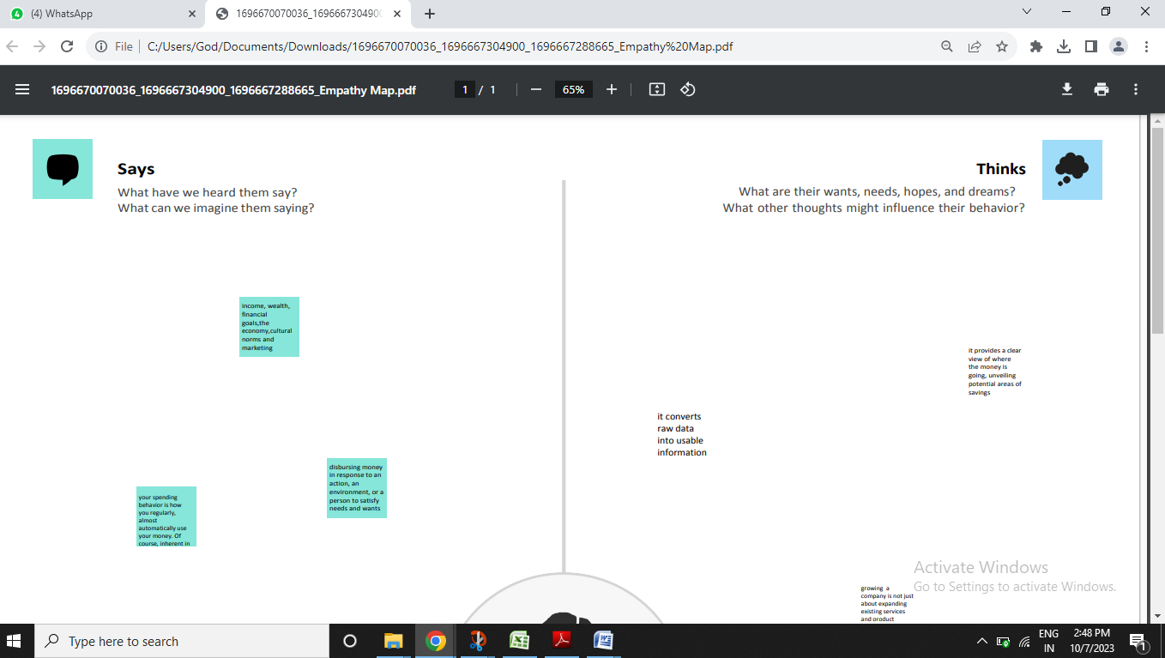

**2.2 Ideation & Brainstorming Map**

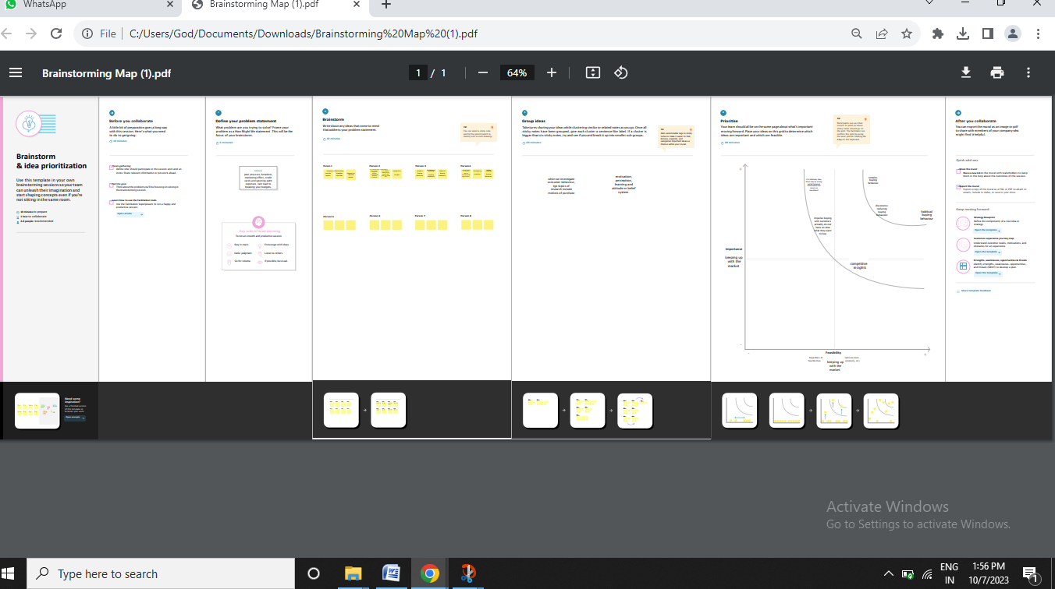

**3. Result**

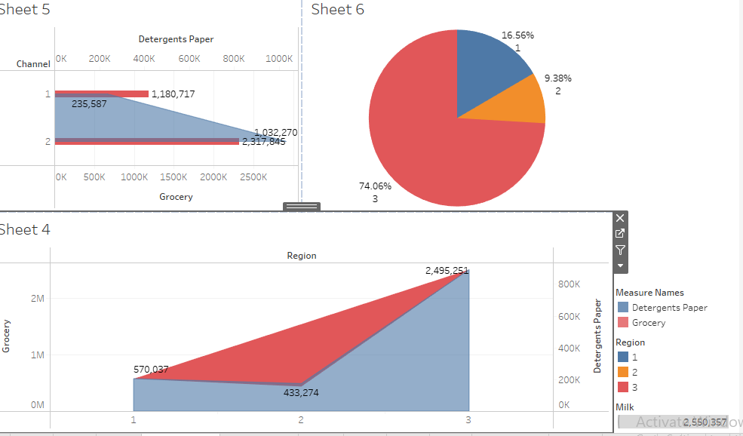

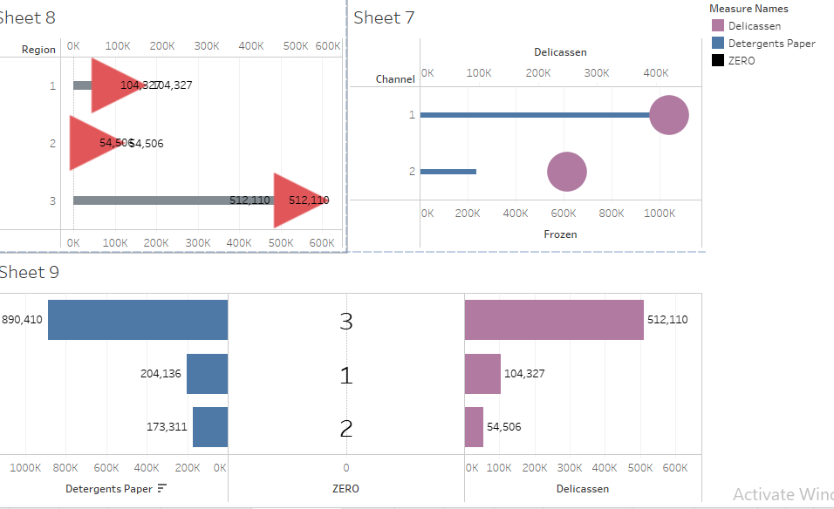

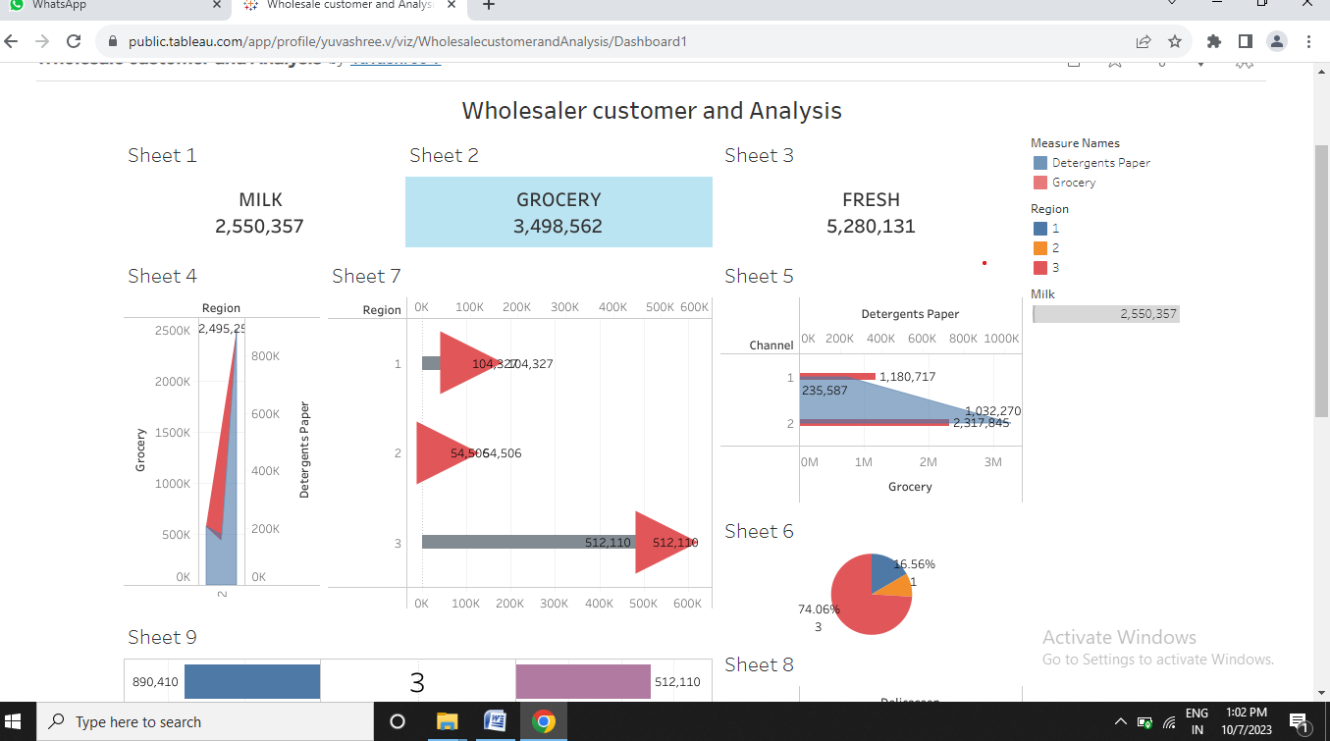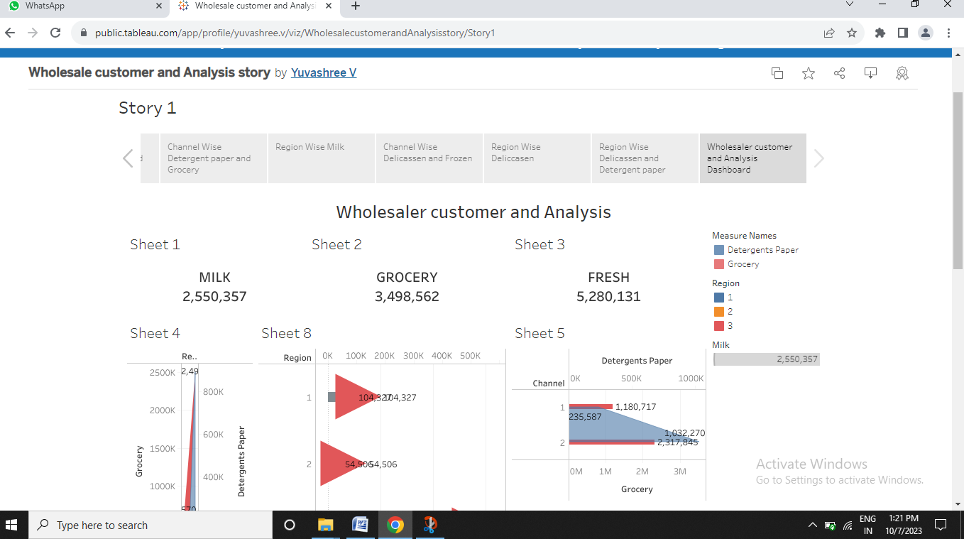

**4. Advantages:**

The biggest advantage of marketing analytics that helps business is that it allows us to take more scientific approach to the market.

**Disadvantages:**

One of the most common issues in marketing analytics is a surplus of incoming data. This forces you to spend a lot of time and effort to identify which information is most relevant.

**5. Applications**

Marketing analytics enables businesses to analyze key metrics across social channels and compare their brand awareness with competitors. By examining search volumes, web traffic, and social media sentiment, marketers can develop strategies to improve brand awareness and gain a competitive edge.

**6. Conclusion**

We can identify the target groups and their various industries and you can determine customer requirements and customer behavior. For example, develop suitable marketing strategies for your business.

**7. Future scope**

It is expected to continue to the increasing amount of data being generated, the growing importance of data-driven decision-making in business, and the continued development of big data and AI technologies.